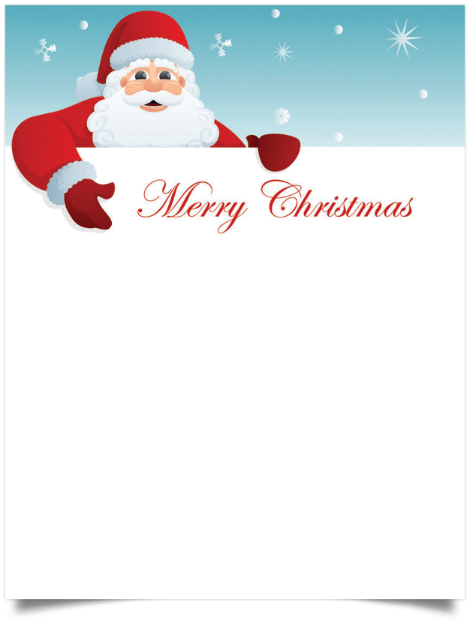

**Dear NAME,**

What an exciting time of year for us here at the North Pole! The elves and I have been very busy getting all the toys loaded into the sleigh. I can hardly wait to fly into **TOWN** with presents just for you.

I know you have been a good **GIRL/BOY**, because I have checked my list twice, and your name is definitely on it. I see that you have been **GOOD DEED HERE**. You’ve become very special and talented. I see a **PRESENT** is on your wish list this year. I will try my best to see that you get just what you asked for.  
  
Don't forget, you need to be asleep before I can visit your house on Christmas Eve. The reindeer and I will try to be quiet so that we don't wake you. We'll need to be quick, since we'll still need to visit your friend **FRIEND-NAME**'s home before morning.

**Love,**

**Santa Claus**