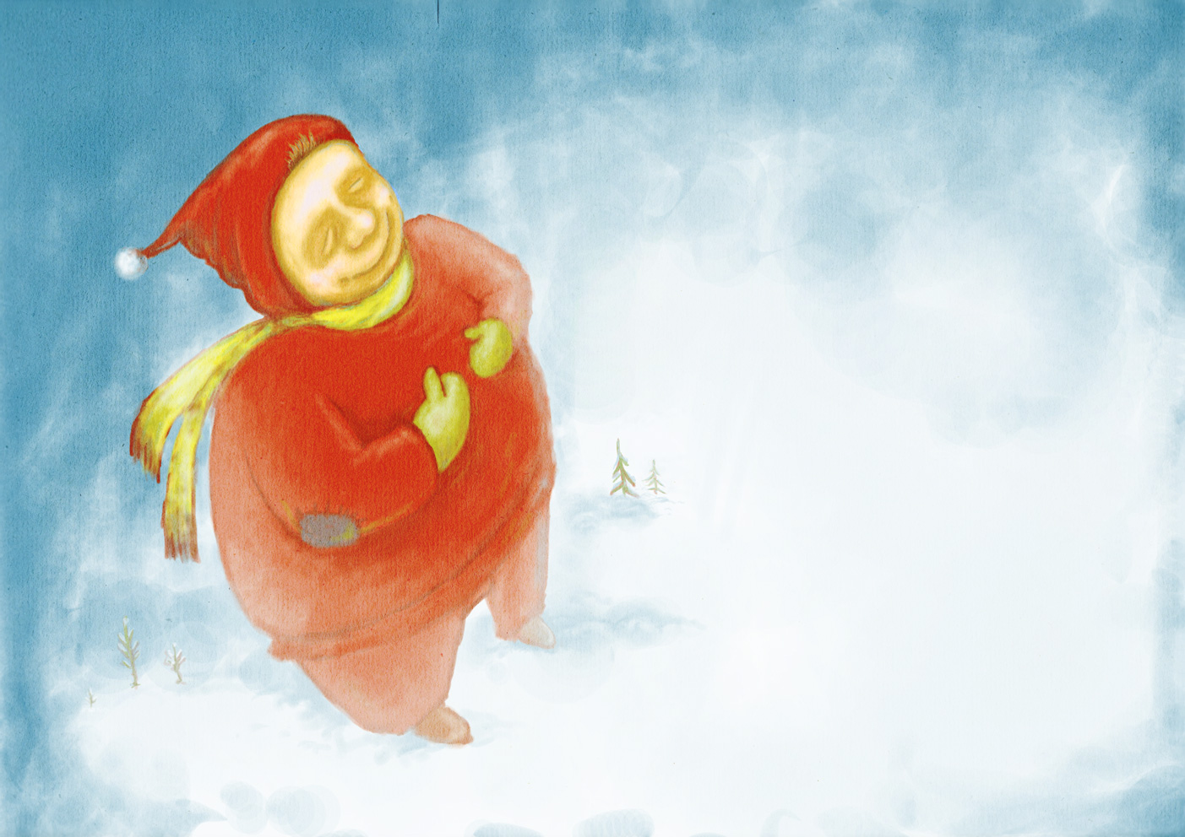

**Santa Claus** hereby declares that:  
NAME HERE has shown goodness, specialness, manners and love of laughter to earn the rating of **100% NICE in 2013**.

Great work!

(Santa tip: Keep brushing your teeth)